# MANAV RACHNA INTERNATIONAL INSTITUTE OF RESEARCH AND STUDIES

**School of Computer Applications**

**COURSE NAME: Web Technologies (4.5CA152C01)**

**ASSIGNMENT: II**

|  |  |  |
| --- | --- | --- |
| **Submitted By** | | |
| **Student Name** | **Dev Arora** |
| **Roll NO** | **24/SCA/BCA/008** |
| **Program** | **Bachelor of Computer Application** |
| **Semester** | **1st Semester** |
| **Department** | **Computer Application** |
| **Section** | **1A** |
| **Batch** | **2024-25** |

Q1: What does CSS stand for? Name three types of CSS. List three common properties used in CSS for styling text. L-1

Solution : CSS stands for Cascading Style Sheets. Three types of CSS are inline CSS, internal CSS, and external CSS. Common properties for styling text include font-family, font-size, and color.

Q2: Explain the difference between internal, external, and inline CSS. L-2

Solution : **Internal, external, and inline CSS** are different ways to apply styles to HTML documents.

1. Internal CSS : This is defined within a <style> tag in the <head> section of an HTML document. It applies styles to that specific document. This method is useful for styling a single page without affecting others.

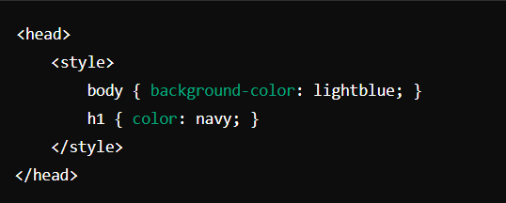

1. **External CSS**: This involves linking to an external stylesheet using the <link> tag in the <head> section. This method allows multiple HTML documents to share the same stylesheet, promoting consistency and easier maintenance.

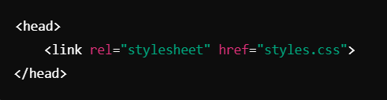

1. **Inline CSS**: This is applied directly to HTML elements using the style attribute. It affects only that specific element, making it useful for quick, one-off styles but not recommended for extensive styling due to reduced maintainability.

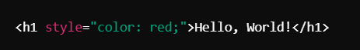

Q3: How does the position: absolute differ from position: relative? L-2

Solution:

1. **Positioning Context**:

* **position: relative**: The element is positioned relative to its original position in the document flow. Offsets (top, right, bottom, left) move it from where it would normally be, but it still occupies space in the layout.
* **position: absolute**: The element is positioned relative to the nearest ancestor that is positioned (i.e., has a position of relative, absolute, or fixed). If no such ancestor exists, it is positioned relative to the viewport. It does not occupy space in the layout, meaning it can overlap other elements.

1. **Impact on Layout**:

* **position: relative**: Other elements still consider the space of the relatively positioned element, so it affects the layout around it.
* **position: absolute**: The absolutely positioned element does not affect the layout of other elements, which can lead to overlap or changes in how other elements are displayed.

**position: relative keeps the element in the document flow, while position: absolute removes it from the flow and positions it based on its ancestor.**

Q4: Describe the difference between id and class selectors in CSS. L-2

Solution: **Difference between ID and class selectors in CSS:**

1. **Syntax and Usage**:

* **ID Selector**: Defined with a # followed by the ID name. An ID should be unique within a page, meaning it can only be applied to one element. For example:

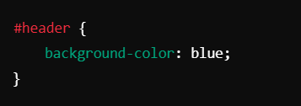

* **Class Selector**: Defined with a . followed by the class name. A class can be applied to multiple elements, allowing for greater flexibility. For example:

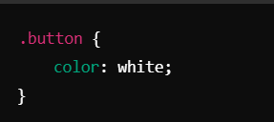

1. **Specificity**:

* **ID Selector**: Has a higher specificity than class selectors. This means that if both an ID and a class are applied to the same element, the styles from the ID selector will take precedence.
* **Class Selector**: Has a lower specificity compared to ID selectors. This allows for broader styling rules that can be overridden by more specific rules.

**IDs are unique and more specific, while classes are reusable and flexible.**

Q5: Use CSS to create a hover effect that changes the text color of a button when a user hovers over

it. L-3

Solution:

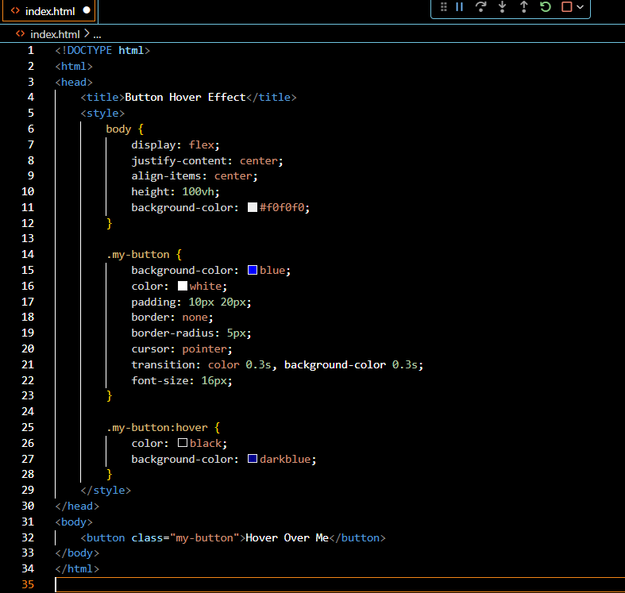

Output Will be:

**Before Hover:**

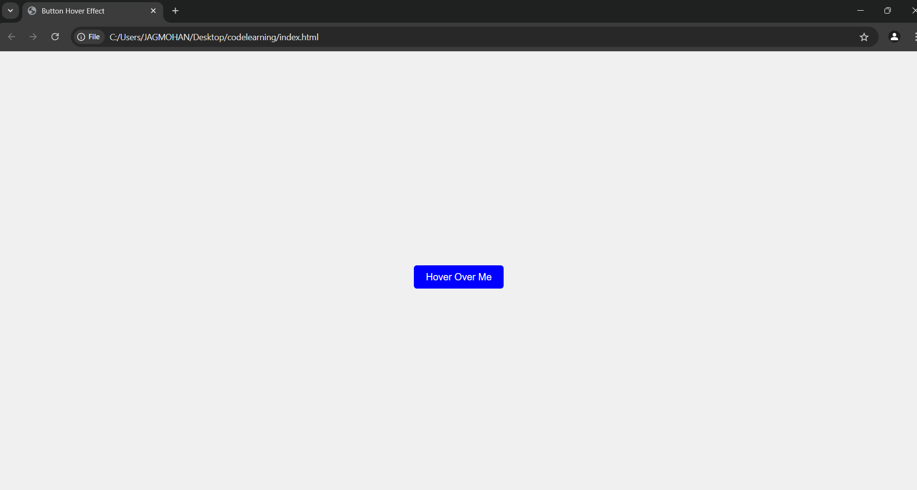

**After Hover:**

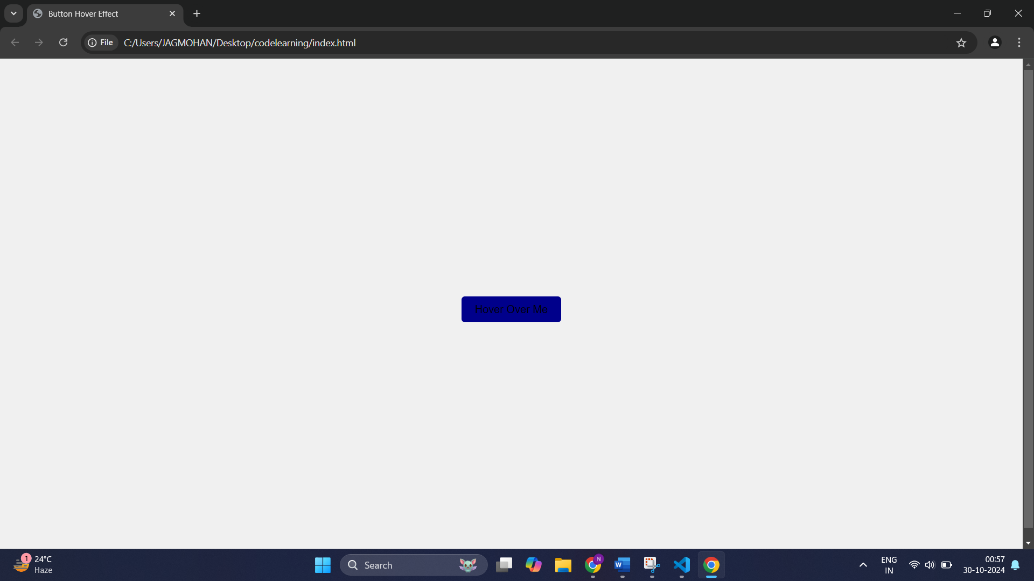

Q6: Style a form using CSS so that the input fields have a specific width, border color, and padding. L-3

Solution:

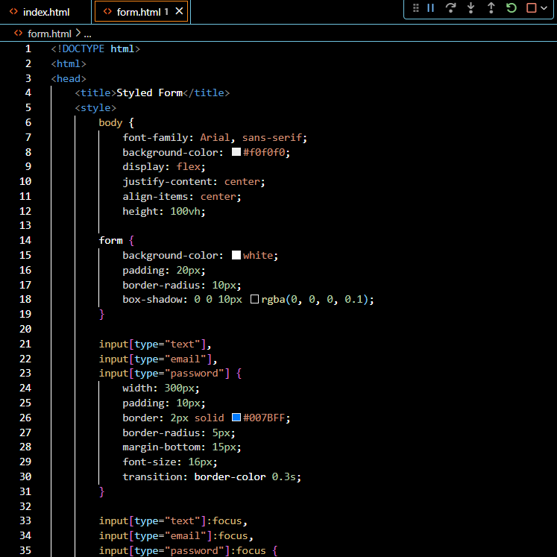

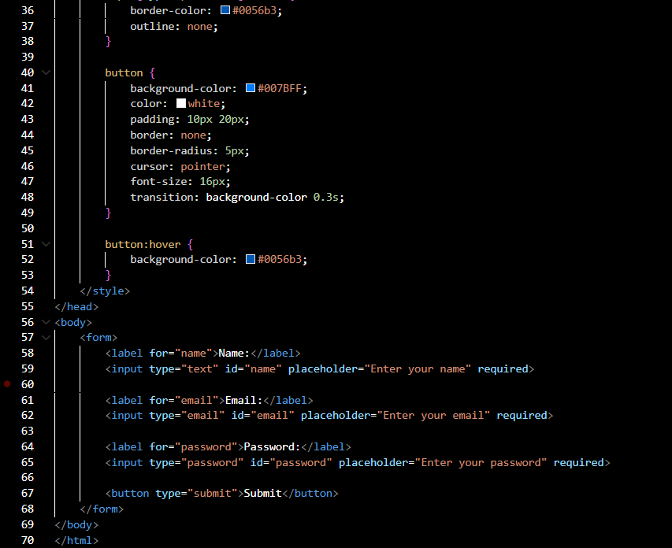

Output Will be :

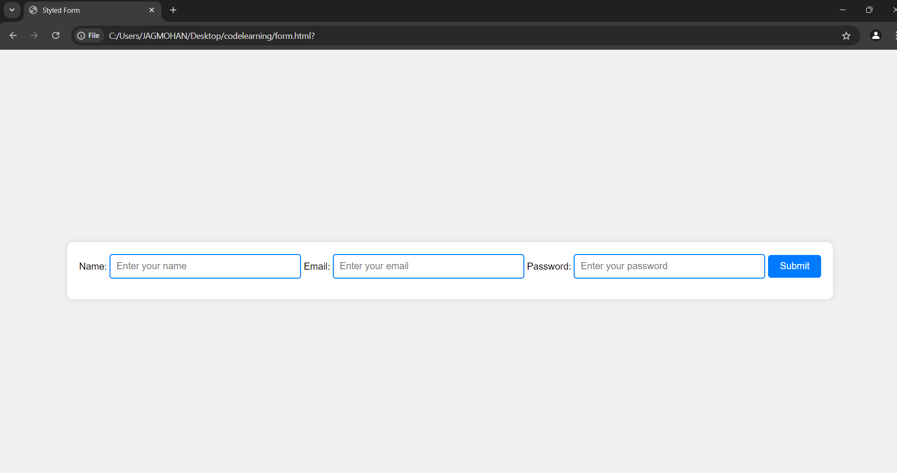

Q7: Break down the structure of a CSS rule and explain each part of it. L-3

Solution:

**Structure of a CSS Rule**

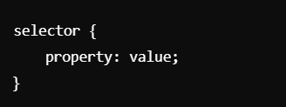

**Components Explained**

1. **Selector:**

* **The selector specifies which HTML elements the styles will apply to. It can target elements by type (e.g., p for paragraphs), class (e.g., .classname), ID (e.g., #idname), or other attributes.**

1. **Declaration Block:**

* **The declaration block is enclosed in curly braces {} and contains one or more declarations that define the styles to apply.**

1. **Declaration:**

* Each declaration consists of a **property** and a **value**, separated by a colon :. The property defines what aspect of the element you want to style (like color, font-size, margin, etc.), and the value specifies how that property should be styled.
* Multiple declarations are separated by a semicolon ;

**For Example :**

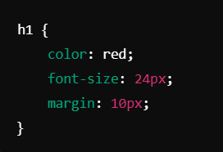

1. **Selector: h1**

* **This targets all <h1> elements in the HTML document.**

1. **Declaration Block:**

* **{ color: red; font-size: 24px; margin: 10px; }**

1. **Declarations:**

* **Color : red; : This sets the text color of <h1> elements to red.**
* **font-size: 24px; : This sets the font size of <h1> elements to 24 pixels.**
* **margin: 10px; : This adds a 10-pixel margin around each <h1> element.**

Q8: Construct a CSS stylesheet for a form that uses advanced selectors, pseudo-classes, and media

queries. L-4

Solution: